**Color Mixer**

# Author = Darren Isaacson

# This program is designed to create mix colors based off what the user has for colors.

#This allows the user to choose 2 colors

color1 = input("Choose a color between red, blue, and yellow to mix. ")

color2 = input("Choose another color you want to mix between red, blue, and yellow. ")

# Red + Yellow = Orange

if color1 == "red" and color2 == "yellow" or color1 == "yellow" and color2 == "red" :

# Displays color

print("The results of the mix is: Orange!")

# Red + Blue = Purple

elif color1 == "red" and color2 == "blue" or color1 == "blue" and color2 == "red" :

print("The results of the mix is : Purple!")

# Red + Red = Red

elif color1 == "red" and color2 == "red":

print("The results of the mix is : Red!")

# Blue + Yellow = Green

elif color1 == "blue" and color2 == "yellow" or color1 == "yellow" and color2 == "blue" :

print("The results of the mix is : Green!")

# Blue + Blue = Blue

elif color1 == "blue" and color2 == "blue" :

print("The results of the mix is : Blue!")

# Yellow + Yellow = Yellow

elif color1 == "yellow" and color2 == "yellow" :

print("The results of the mix is : Yellow!")

# Error for any other colors that were not listed

else :

print("Error! You tried unavailble colors.")

print("End of program")

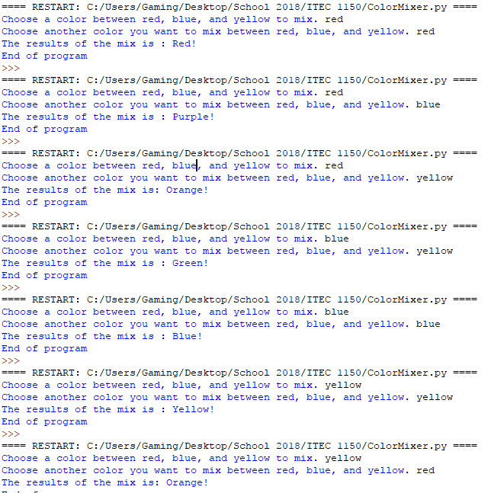

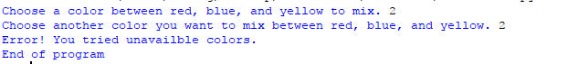

**Coin Counter**

# Author = Darren Isaacson

# This program is designed to calculate the amount of money someone has and convert it into dollars

# Created base variables for coins

quarters = 25

dimes = 10

nickels = 5

pennies = 1

# Input varibles to find the how many coins for each different coin

countQuarters = int(input("How many quarters do you have? "))

countDimes = int(input("How many dimes do you have? "))

countNickels = int(input("How many nickels do you have? "))

countPennies = int(input("How many pennies do you have? "))

# Calculating the coins based off their differences

totalQuarters = quarters * countQuarters

totalDimes = dimes * countDimes

totalNickels = nickels * countNickels

totalPennies = pennies * countPennies

# Total out all the coins into a penny conversion

totalTogether = totalQuarters + totalDimes + totalNickels + totalPennies

# Created a condition based off the total amound of pennies

# Equal to a dollar

if totalTogether == 100:

print("\nYou have exactly 1 dollar\n")

# Less than a dollar

elif totalTogether > 100:

print("\nYou have less than a dollar\n")

# More than a dollar

elif totalTogether < 100:

print("\nYou have more than a dollar\n")

# Anything else

else :

print("\nYou have no money\n")

# This output is creating a table of information for the info given

print("\t\tAmount\tCount\tTotal")

print("Quarters\t" + str(quarters) + "\t" + str(countQuarters) + "\t" + str(totalQuarters))

print("Dimes\t\t" + str(dimes) + "\t" + str(countDimes) + "\t" + str(totalDimes))

print("Nickels\t\t" + str(nickels) + "\t" + str(countNickels) + "\t" + str(totalNickels))

print("Pennies\t\t" + str(pennies) + "\t" + str(countPennies) + "\t" + str(totalPennies))

# Total amount of pennies output

print("\nYou have",totalTogether,"Pennies")

print("\nEnd of program")

